**Meetings**

**1. Planning Meetings**

The following questions will guide you in arranging meetings:

* How many attendees will there be?
* Who are the attendees?
* What are their contact details?
* When should the meeting take place?
* What style of seating do you need (boardroom, lecture theatre, circle of chairs)?
* Is a seating plan needed?
* What equipment do you need for any presentations?
* Where is the best location?
* What refreshments are needed?

**Agenda:** An agenda is essentially a meeting plan that outlines what topics will be discussed and in what order. Agenda items depend on the meeting’s purpose and the needs of your business or team. An agenda for a staff or board meeting may be very different from that for a conference or seminar, but the goals are the same: to inform meeting participants about what topics will be covered and to allow for easy facilitation of the meeting process. Having a well-planned agenda doesn’t guarantee that a meeting will run smoothly, but if problems do arise, the agenda can help members identify and address the problems and get back on track. A clear agenda also makes it easier to record effective [meeting minutes](https://www.smartsheet.com/free-meeting-minutes-templates-microsoft-word).

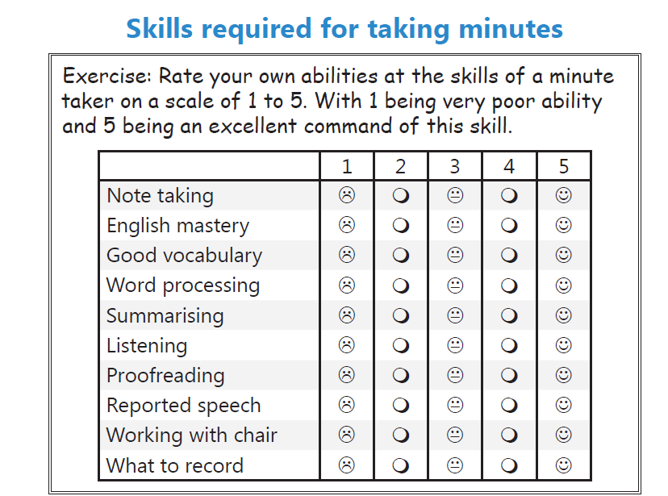

**MEETING MINUTES:**

Clear, organized and well-structured. Those are the hallmarks of effective meeting minutes. Meetings can be a fantastic collaboration tool. Often, however, participants invest time and energy into a meeting only to disagree later on what occurred. Meeting minutes can prevent these disagreements by providing an accurate depiction of the essential information from the meeting. Taking effective meeting minutes does not have to be an exhausting and laborious process, however. Here are six quick tips for taking effective meeting minutes.

Writing minutes has two major aspects to it:

1. Observation and note taking while the meeting is in progress
2. Writing a report on the meeting with all details discussed with clarity and precision.

**For note taking, follow the guidelines below:**

* Make sure that all of the essential elements are noted, such as type of meeting, name of the organization, date and time, name of the chair or facilitator, main topics and the time of adjournment. For formal and corporate meetings include approval of previous minutes, and all resolutions.
* Prepare an outline based on the agenda ahead of time, and leave plenty of white space for notes. By having the topics already written down, you can jump right on to a new topic without pause.
* Prepare a list of expected attendees and check off the names as people enter the room. Or, you can pass around an attendance sheet for everyone to sign as the meeting starts.
* To be sure about who said what, make a map of the seating arrangement, and make sure to ask for introductions of unfamiliar people.
* Don't make the mistake of recording every single comment, but concentrate on getting the gist of the discussion and taking enough notes to summarize it later. Remember that minutes are the official record of what happened, not what was said, at a meeting.
* Use whatever device is comfortable for you, a notepad, a laptop computer, a tape recorder, a steno pad, shorthand. Many people routinely record important meetings as a backup to their notes.
* Be prepared! Study the issues to be discussed and ask a lot of questions ahead of time. If you have to fumble for understanding while you are making your notes, they won't make any sense to you later.
* Don't wait too long to type up the minutes, and be sure to have them approved by the chair or facilitator before distributing them to the attendees.
* Don't be intimidated, you may be called upon many times to write meeting minutes, and the ability to produce concise, coherent minutes is widely admired and valued.

**For writing the report, follow the guidelines below:**

1. Begin with a succinct overview of meeting details. Document the meeting date and/or time and a description of the meeting’s purpose. Also give the meeting minutes a brief title. Locate this information at the top of the document as this will provide the reader with the at-a-glance context required to understand the minutes

2. Capture participation. Keep in mind that the reader may not be familiar with all participants. Document a participant’s name as well as some identifying information such as title or role in the discussion. In some instances it may be useful to list all invitees and mark attendance with a “Yes” or “No” value so there is a record of participants who were invited but were not present for the discussion. On a related note, it may be useful to distinguish participants who may have been able to participate for only part of the meeting; this can be done with something as simple as a third attendance value, for example: “Yes (partial)”.

3. Structure information in a clear and readable format. A few quick tips to ensure clarity:

* Always spell out acronyms. While it may be obvious during the meeting that OFA stands for Our Favorite Acronym, chances are that this may not be clear to future readers.
* Do not capture the conversation verbatim. It may sound useful to capture the conversation in its entirety, but this is rarely the best way to document discussions. Often participants meander about a topic, jump between topics, think out loud, etc… Documenting all of this verbatim requires the reader to invest significant effort in following the thread of the conversation.
* Use visual cues to structure data and call out key elements. Bullets can be used to combine related points and bolding can be used to highlight decisions which were made. If a single meeting covered multiple topics, use underlined headers to separate these conversations. With these simple style guidelines, readers can scan the meeting minutes and find the portion that is of importance to them.
* Structure discussion points in a logical order, not in the sequence they occurred. For example, a topic may be introduced at the beginning of the meeting and later a second topic may be introduced. Participants may occasionally make comments related to the first topic – these comments can be grouped under the first topic header, so that the reader can see all related information in one section.
* Often visual aids or other materials are used as references for the discussion. Include these items in the minutes so that the reader has the appropriate information required to understand the conversation.

4. Capture next steps. Almost every meeting results in a set of action items. It’s a common occurrence that participants will fully agree with action items during the meeting, but after the meeting will forget who owns a given item or what the expected completion date is. Capturing action items, the assigned owner or owners and the expected completion date (if relevant) ensures that there is no confusion after-the-fact.

5. Document meeting minutes as soon as possible. The longer you wait to document the meeting minutes, the less likely you are to capture information accurately.

**WRITING MEETING MINUTES**The minutes, an organization’s official record of a meeting, are distributed to all those who belong to the committee or any other unit represented at the meeting. In writing a set of minutes, your goal is to be clear, comprehensive, objective, and diplomatic. Your job is not to interpret what happened. You have three main goals:

1. to record the logistical details of the meeting  
2. to provide an accurate record of the meeting   
3. to ensure that minutes reflect positively on the participants and the organization

**Recording the Logistical Details of the Meeting**According to Robert's Rules of Order (Robert & Patnode, 1994), the authoritative reference work on parliamentary procedure, you should record the following information:

1.the name of the group or committee that met  
2.the location, date, and time of the meeting  
3.the type of meeting (regular or special)  
4.the presence of the chair and secretary, or their substitutes  
5.the time at which the meeting was adjourned

Another respected source, the Gregg Reference Manual (Sabin, 1999), suggests that you include the names of those who attended and those who did not and a separate list of guests.

Also record what action was taken about the minutes of the previous meeting. For example, the minutes were read (or distributed) and approved (or amended and approved). You should record any changes to the previous minutes.  
  
**Providing an Accurate Record of the Meeting**  
Because meetings rarely follow the agenda perfectly, you might find it challenging to provide an accurate record of the meeting. Record the major topics discussed at the meeting as well as any actions taken. For example, write down the names of reports read or approved, motions made (and whether they were approved, defeated, or tabled), and resolutions adopted. Record the outcomes of discussions. Record the names of the people who made motions, read reports, and so forth; for example, "Barry Young presented a report on the June activities of the Safety Department." If the conversation is going too fast for you to keep an accurate record, interrupt the discussion to request a clarification.

**Reflecting Positively on the Participants and the Organization**Your task in recording the minutes includes separating the substance of the meeting from the emotional exchanges of participants. Do not write: "The motion to add a new position in the QA Department was defeated 7 to 6 after a heated argument in which Bob Minor complained that 'Alice states that she-supports my department, but when it comes to action, she's all talk.' " Instead, write: "After considerable discussion, the motion to add a new position in the QA department was defeated by a vote of 7 to 6." Sometimes the smartest thing a recording secretary can do is choose not to record what was said.

**Revision Checklist:** Do the minutes:  
a. provide the necessary housekeeping details about the meeting?  
b. explain the events of the meeting accurately?  
c. reflect positively on the participants and the organization?

**Exercise: Select the correct spelling from the options given in these sentences:**

1. He had been practising/practicing medicine for years.

2. It was a nice compliment/complement about my work.

3. The principal/principle reason why the project succeeded was the team management.

4. The chairperson was concerned about the affect/effect this would have on the practise/practice time.

**Exercise: Add any missing apostrophes.**

1. The clients rooms are nearby. (three clients)

2. The managers response was “no”. (one manager)

3. The secretaries attitude must improve.

4. The mens preference was to sit down.

5. The caretaker says that hes happy with this plan.

6. Youre not sure what your choice will be.

7. Its difficult to know if the company and its representatives are included.

8. The SATs were very difficult.

**Exercise: Re-write the following paragraph to avoid repetition and to flow better.**

It was agreed that there was a very good chance that the manager would tell the department what she was going to do. The chairperson said that the CEO had said that everyone should be told about the fact that there could well be redundancies. She also said that she thought this would happen.

**Exercise: Think of ways to improve these phrases and avoid repetition.**

1. Jon Smith (JS) brought the sales figures to the meeting. These were distributed to the members of the Committee and discussed and Jane Adams (JA) agreed they had improved. All other attendees agreed they had improved too. It was agreed that a bonus could be paid this year.

2. The repairs needed to the new offices were discussed. It was quite rightly agreed that the walls needed painting, the windows needed replacing and the doors needed replacing. Mr Jones agreed to contact the Board to get their permission to carry out

these repairs.

3. JS asked the Committee for their views on the proposed new pay system. JA said she thought it was good, HB said he thought there some issues which should be looked at in more detail. JS and JA agreed with this. These issues were then discussed and everyone then agreed that they would go ahead with this new system.

4. The Committee discussed the half year sales figures ending 30th June. It was noted that a profit of £13 million had been made in the first 6 months of the year.